Walls

Great wall of China, Hadrian’s Wall – famous ancient walls has different purposes from modern walls.

Berlin Wall, Berlin was half governed by USSR, and the western Europe. Wall were built to prevent emigration due to political pride and sovereignty. Finally brought down on 1989. Symbolises political division in the world. It is easy to create an identity when there is an enemy, which can be reinforced by the wall.

West bank wall (Israel) – illegal wall built by Israel. Official reason is to prevent terrorism for defensive purposes. The wall is not on Israeli land. The way the wall was built was to deny Palestinians political rights.

Walls = sovereignty (protect our space), spatial rejection and exclusion. The wall further legitimises it this exclusion and discrimination.

Private Property

Private property is the relationship between a person and all the others instead of a relationship between a person and an object. Private property is the closest relationship we can get to something that is god-like. Property has an absolute right and unconditional. Private property has the right to use it, abuse it and enjoy the fruits of it (“Usus, abusus, fructus”). Property of land must be manifested visually (seen as mine and reaffirmed as mine). Private property is an act that needs to be constantly reiterated because private property is a mere notion.

Essence – is that without which, the thing cannot be and cannot be thought. (Eg. Socrates is a man.)

Accident – is that without which, the thing can still be and be thought. (Eg. Socrates is sleeping.)

Necessary – is that which cannot be otherwise than it is. (iff)

Contingent – is that which could be otherwise than it is.

Indigenous vs the whites regarding wild land. Indigenous people regarded wild land as sacred (don’t abuse it, it is sacred). Whites regarded wild land as unowned and possible for their appropriation and exploitation (nobody is taking care of it/showing that it is theirs, nobody owns it).

Terra Nullius – is land owned by no one.

Subjective – is that which depends on or relates to the subject

Objective – is that which relates to or depends on the object.

Maps

Subjective – is that which depends on or relates to the subject

Objective – is that which relates to or depends on the object.

Maps pretend to say nothing about power (objective). Mercator Projection was to respect the distance between places (navigation purposes) [common]. The Galls-Peters projection respect the sizes of countries. The North was decided to be at the top of the map because of Europeans. Maps are not just reflection of power, it also legitimises the power.

Gerrymandering – cutting up of the map to favour politics. (Basically, GRC.)

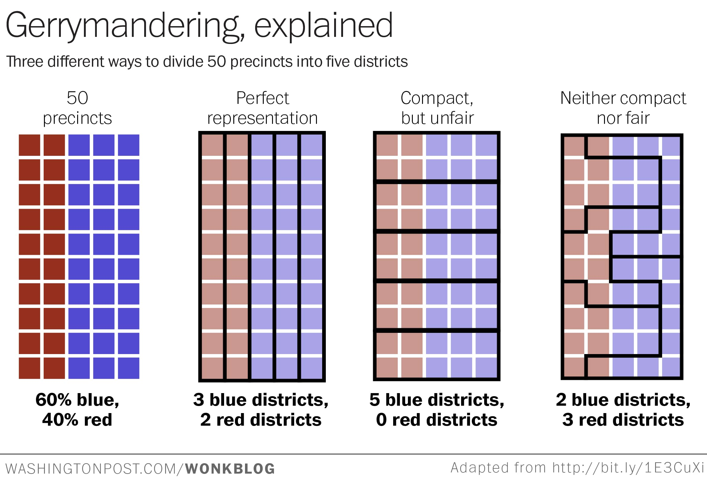

Maps introduce order and rationality to people (as seen by straight lines and blocks in map).

Treaty of Tordesillas, 1494 – first time it happened when the map was divided for politics.